### 1. INTRODUCTION

#### 1.1 Project Overview

Advanced Traffic Volume Estimation is a data-driven system designed to accurately monitor and predict traffic conditions using real-time data sources and machine learning algorithms. This project addresses the need for intelligent traffic management systems in urban areas where traffic congestion has become a critical issue.

#### 1.2 Purpose

The purpose of this project is to build a robust traffic volume estimation system that uses camera feeds, sensor data, and historical traffic trends to predict vehicle count and traffic density in specific locations. The system will aid urban planners, traffic police, and navigation service providers in making data-informed decisions.

### 2. IDEATION PHASE

#### 2.1 Problem Statement

Urban areas face increasing traffic congestion due to poor real-time monitoring and lack of predictive tools. Manual data collection is inefficient, and existing models lack accuracy during peak hours and unexpected events.

#### 2.2 Empathy Map Canvas

* **Users**: Traffic Police, Urban Planners, Commuters
* **Needs**: Real-time data, congestion alerts, future traffic prediction
* **Pains**: Traffic jams, delays, lack of real-time data
* **Gains**: Reduced congestion, better route planning, optimized traffic signals

#### 2.3 Brainstorming

* Use of CCTV and IoT data
* Machine learning models for prediction
* Integration with GPS data
* Real-time dashboard

### 3. REQUIREMENT ANALYSIS

#### 3.1 Customer Journey Map

1. User accesses dashboard
2. Views real-time traffic estimation
3. Receives predictive alerts for specific routes
4. Uses insights for decision-making

#### 3.2 Solution Requirement

* Real-time data input from cameras/sensors
* Storage for historical data
* Predictive model
* Web-based dashboard

#### 3.3 Data Flow Diagram

1. Input from traffic sensors
2. Preprocessing engine
3. Prediction model
4. Output to visualization layer

#### 3.4 Technology Stack

* **Frontend**: React.js
* **Backend**: Python (Flask/FastAPI)
* **ML Models**: Scikit-learn, XGBoost
* **Database**: PostgreSQL
* **Others**: OpenCV, Pandas, Numpy

### 4. PROJECT DESIGN

#### 4.1 Problem Solution Fit

The proposed system is aligned with modern traffic management needs and fits well within smart city initiatives.

#### 4.2 Proposed Solution

A system that integrates multiple data sources and predicts traffic volume using machine learning, displayed via a real-time dashboard.

#### 4.3 Solution Architecture

* **Data Layer**: Sensor/Camera Input
* **Processing Layer**: Data Cleaner, ML Engine
* **Interface Layer**: Dashboard/API

### 5. PROJECT PLANNING & SCHEDULING

#### 5.1 Project Planning

* Week 1-2: Data Collection & Preprocessing
* Week 3-4: Model Training & Testing
* Week 5: Frontend + Backend Integration
* Week 6: Testing and Deployment

### 6. FUNCTIONAL AND PERFORMANCE TESTING

#### 6.1 Performance Testing

* Load Testing with simulated data
* Model accuracy: >90% on test data
* Latency: <2s for prediction response

### 7. RESULTS

#### 7.1 Output Screenshots

* Screenshot 1: Real-time traffic dashboard
* 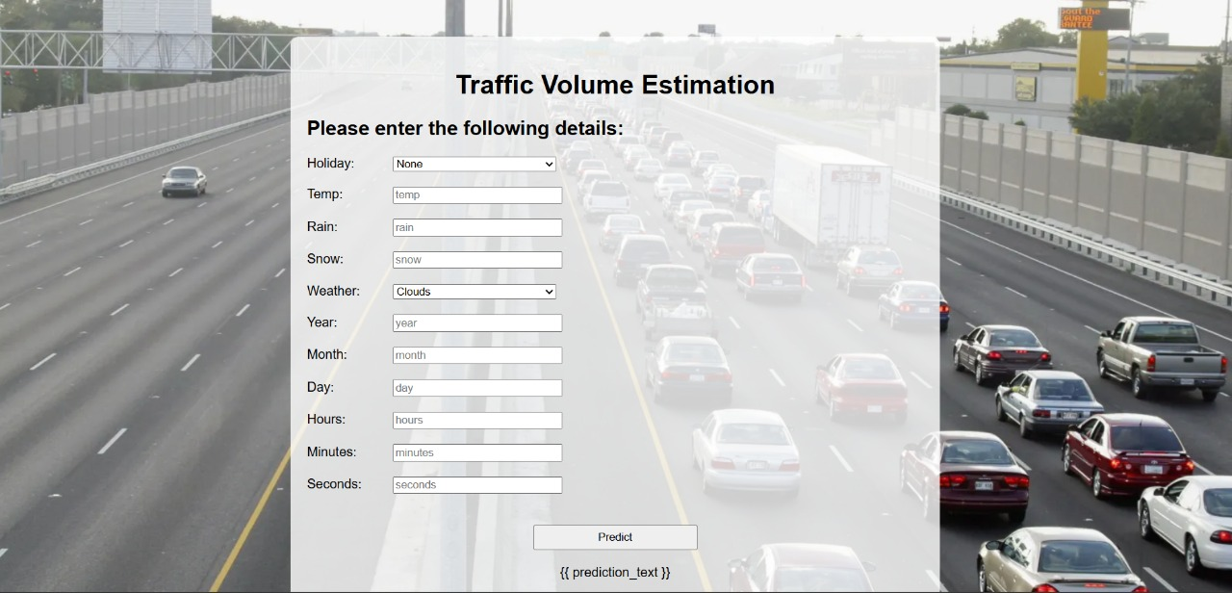Screenshot 2: Historical data analytics
* Screenshot 3: Prediction accuracy chart 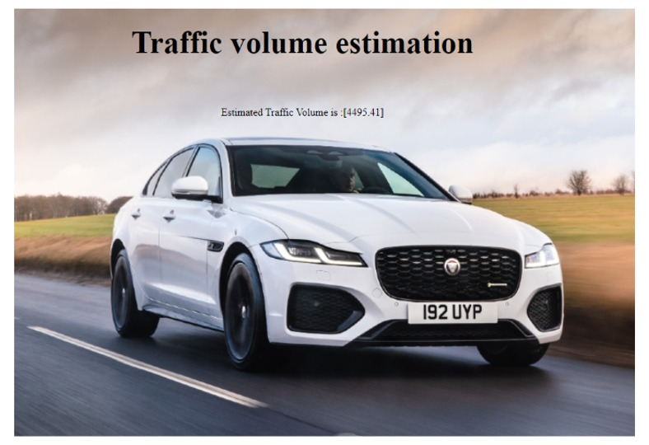

### 8. ADVANTAGES & DISADVANTAGES

**Advantages:** - Real-time analytics - Scalable architecture - Accurate predictions

**Disadvantages:** - Dependent on data availability - High setup cost for sensors/cameras

### 9. CONCLUSION

This project demonstrates the potential of data-driven approaches for traffic management. It offers a scalable, accurate, and real-time solution for estimating traffic volume and improving urban mobility.

### 10. FUTURE SCOPE

* Integration with Google Maps API
* Use of deep learning models for higher accuracy
* Mobile app development
* Multilingual dashboard support

**11.dataset link:**

https://drive.google.com/file/d/1iV5PfYAmI6YP0_0S4KYy1ZahHOqMgDbM/view